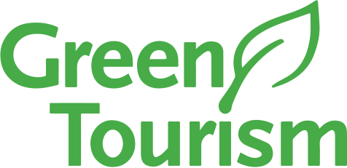

The Pines Hotel - Our Green Story
Our Green Story officially began in March 2026 – as a busy seaside hotel in the heart of the Purbecks and located on the Jurassic Coast, we have always been aware of the impact our business has on our beautiful and fragile environment but this is the year we take responsibility and seriously up our game.
We are setting ourselves a challenge of reaching a Gold award from Green Tourism within 2 years. Fortunately, we are an independent hotel with a close knit team of around 50 people from all walks of life. We don’t have to adhere to large company policies and we can benefit from the ideas and enthusiasm of our team members who will all bring various suggestions and ideas to the table. We are sure our wonderful guests will also bring us fresh suggestions as we progress.
The Pines Hotel started out as three separate dwellings dating back to the early 19th century and therefore because it was not originally designed with modern sustainability standards in mind, we recognise that improving our environmental performance will present some significant challenges, particularly in areas such as energy efficiency.
We were delighted to learn that during our initial assessment process, we were already on the right track with many aspects of Green Tourism and its criteria. We are looking forward to the challenge and knowing that we are contributing to showing our commitment to sustainability and reducing our environmental impact.
Our first steps will be to have a more meaningful presence on social media, implementing information to be on display in our bedrooms to encourage guests to be taking part and working very hard behind the scenes with our various departments to work together and take steps forward. All of this whilst continuing to run a busy clifftop hotel, the largest in Swanage.
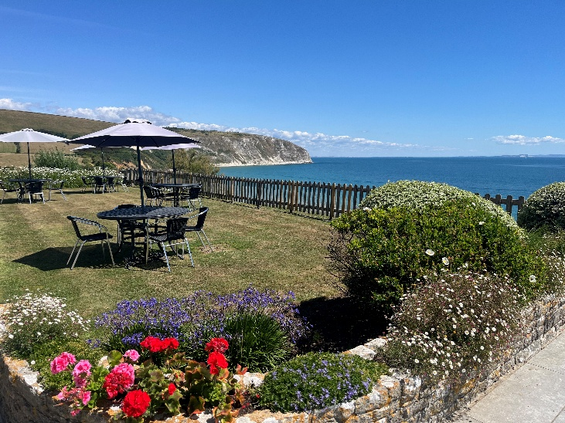
We are proud to be a member of Green Tourism and hope that others will be inspired and think about their own impact. Watch this space and keep an eye on our website and social media channels for updates and to see how we progress!

